

# September 14-15, 2019

# Mission Pack

Mission Guidelines

This section describes the format Guidelines for the East China Open. In this section, you will find the rules for pre-game setup, including deployment and scoring for Primary and Secondary missions. Unless otherwise stated, all of the five missions listed below follow these steps.

任务指南

本章节描述了华东战锤公开赛的比赛赛制。在本章中，您将读到游戏对局前准备相关的规则，包括部署方式，以及主要和次要任务的计分规则。

除非专门指出，默认下述五个任务均按下列步骤进行。

# Pre-Game, Deployment, & Setup

对局前准备，部署与设置部队

## Pre-Game

**Step 1**: Before any dice are rolled, players adjust and define terrain on the board, then both players choose Warlord Traits, Psychic Powers, spend pre-deployment command points, free relic, and any additional Relics they wish to use. These should be written or notated clearly for reference in game.

**Step 2:** Players reveal the items from step 1 to each other simultaneously.

Deployment Map & Objectives

**Step 1:** Players roll off for deployment.

**Step 2:** The player who rolled higher randomly determines the deployment type from the maps on pg. 216-217 of the 40k Main Rulebook, and then chooses their deployment zone.

**Step 3:** Players then place objectives following scenario guidelines as listed on each mission. Instructions for placing objectives are as follows:

**A:** All objectives are considered to be on the ground floor and may not be placed inside of enclosed buildings. Move terrain if necessary to accommodate this requirement.

**B:** Distances are measured to and from models to the closest point of the objective marker when determining which models are in range to control an objective.

**Step 4:** Each player chooses **2** of the Secondary Mission Objectives listed below. A player may only choose each mission once. They then reveal them to their opponent simultaneously.

**Step 5: In missions 2, and 4** The player who lost the roll-off in step 1 deploys the first unit. Deployment proceeds normally thereafter.

部署区域图与任务目标点

步骤1：双方玩家掷骰子拼点。

步骤2：骰子点数较大的玩家，从40K主规则书216-217页所示的部署区域图中，随机选取一种用于本场对局，并选择一个部署区域（另一位玩家则使用另一个部署区域）。

步骤3：双方玩家根据本轮比赛所规定的任务场景要求，放置任务目标点（objectives）。目标点放置要求如下：

1. 所有目标点视为放置于“一楼”，且不得放置于封闭建筑的内部。如果必要，可微调桌上地形的位置，以确保目标点能够放置；
2. 判断模型是否在目标点的控制范围内时，从目标点上距离该模型最近的一点处起（止）进行距离测量。

步骤4：每位玩家从下述次要任务目标中，选取2项。每位玩家只能选择某个任务目标至多1次。双方玩家同时向对方展示自己所选取的结果。

**步骤5：在任务场景2以及4中，步骤1中掷得骰子点数较小的玩家，首先部署1个单位，随后双方玩家正常交替部署单位。任务场景2以及4中，依任务自身规定的部署方式进行部署**

In missions 1, 3, and 5 use the following deployment.

任务场景1, 3 以及5中，依任务自身规定的部署方式进行部署

The players roll off and the winner randomly determines which of the standard deployment maps is used in the battle (see the Warhammer 40,000 rulebook) and picks one of the deployment zones for their army. Their opponent uses the other deployment zone.

双方玩家掷骰子， 骰子点数较大的玩家， 从40K主规则书（216-217页） 所示的部署区域图中， 随机选取一种用于本场对局， 并选择一个部署区域。 另一位玩家则使用相应的另一个 部署区域。

The player who did not pick their deployment zone then chooses to deploy their entire army first or second.

未选择部署区域的玩家， 选择先部署或后部署其所有部队。

The player that deployed first goes first unless the player that deployed second seizes the initiative.

先部署的玩家先手开始游戏对局， 除非后部署的玩家成功“夺取主动权”。

## Determining First Turn

**Step 1: In missions 2, and 4** Players roll off for first turn.

**A:** The player that finished deploying first gets a +1 modifier to the roll to go first.

**Mission 1, 3 and 5 follow their own first turn system**

**Step 3:** The player that wins the roll-off may choose to go first or second.

**Step 4:** The player that is elected to go second by their opponent may choose to roll to seize the initiative.

决定先后手

步骤1：**在任务场景2以及4中，双方玩家掷骰子拼点。**

步骤2A：先完成所有单位部署的玩家，点数结果+1。  
**在任务场景1, 3以及5中，依任务自身规定的部署方式进行部署**

步骤3：点数结果较大的玩家，可以选择先手或后手开始游戏对局。

步骤4：被对手选定为后手的玩家，可以选择掷骰子“夺取主动权（seize the initiative）”。

# Game Length, Tabling & Concession Scoring

游戏长度，清盘与认输的计分

Each game lasts **6 Battle Rounds**. At the game’s conclusion, the player with the ***higher total score*** is the winner. If one player chooses to concede before the game has come to a natural conclusion, they automatically score 0 points and their opponent is marked as the victor. At the time of concession, the victor keeps their current score and earns 4 points per remaining Battle Round towards the Primary Mission, assuming their army has enough forces to accomplish mission objectives. Additionally, the victor also earns the maximum number of possible Secondary Mission points left to them, also assuming the victor’s army has the capability to accomplish the mission objectives.

每轮游戏对局包含6个对战回合（每个对战回合包含2个玩家回合）。对局结束时，总得分更高的一方玩家获得胜利。如果一位玩家在游戏正常结束之前决定认输，则其本轮得分自动记为0分，其对手获得本轮胜利。当一位玩家认输时，记录获胜玩家当时的得分，对局每剩余一个完整的对战回合，该玩家再得4分（假定剩余的兵力足以完成任务目标）。进一步地，获胜玩家将得到次要任务目标中，尚有可能完成的最高分数（亦假设获胜玩家剩余的兵力足以完成任务目标）。

***Example Scenario:*** *If it were the end of Battle Round 3 when the losing player concedes, and the victor chose Recon for their secondary mission, but had not yet scored any points for that secondary mission. The victor would earn 3 total points for the secondary mission as they would have 3 more turns to earn those points had the game continued, assuming they have at least 4 units left on the table with which to fulfill the mission’s scoring parameters. If they have 3 or less units left, they score no points for that Secondary Mission as it would not be possible for them to fulfill the scoring parameters even if the game had gone on to a natural conclusion.*

*情景示例：如果在第3对战回合结束时一位玩家认输，且获胜玩家选定了<侦查>作为次要任务目标，但还未获得此项次要任务分数。获胜玩家若此时在战场上还拥有至少4个单位，则其可得到3分，因对局还有3个回合可供其得到此项分数。获胜玩家若此时仅拥有3个或更少单位，则其在此项次要任务上不能得分，因为若游戏继续正常进行至结束，该玩家已经不具备得到此项分数的条件。*

If one player is tabled (a player has no qualifying models on the table at the end of any player turn), the tabled player keeps their points earned up until that point in the game, and their opponent earns points in the same fashion as outlined above.

If a player draws a bye due to an uneven number of players, this should go to the player with the lowest total score and that player receives a win and a score of 20 points.

如果一位玩家被清盘（在任一玩家回合结束时，战场上已没有任何该玩家操控的模型），被清盘的玩家记录其当时的得分作为本轮得分，而其对手按上述方式计算本轮的总得分。

如果因赛事中当前总玩家数为奇数而需使一位玩家轮空，则由当前各轮总得分最低的玩家获得此轮轮空，记该玩家本轮获胜，得20分。

**Players should take careful note that tabling your opponent does not automatically score maximum points for the mission. Concession also does not automatically award max points to the victor!**

**玩家应切记，将对手清盘并不一定自动使你获得最高的任务分数。认输也不一定自动使对手获得最高的分数。**

# 

# Primary & Secondary Mission Scoring

主要任务与次要任务计分

## Primary Mission: End of Player Turn Scoring

***Each player scores points at the end of their player turn.***

1. Do you hold one or more objectives?
   1. 1 point
2. Was an enemy unit destroyed during your player turn?
   1. 1 point

主要任务：玩家回合末计分

每位玩家在每个自己的玩家回合末记录此项得分

1. 是否控制至少一个任务目标点？是则得1分
2. 是否在你的这一个玩家回合中消灭了至少1个敌方单位？是则得1分

### Primary Mission: End of Battle Round Scoring

***Each Player also scores points at the end of each Battle Round.***

1. Do you hold more objectives than your opponent?
   1. 1 point
2. Were more of your opponent’s units destroyed this battle round than your own?
   1. 1 point

主要任务：对战回合末计分

每位玩家在每个对战回合末各自记录此项得分

1. 是否比对手玩家控制更多的任务目标点？是则得1分
2. 在这一个对战回合中，你消灭敌方单位的数量，是否比对手玩家消灭你的单位的数量更多？是则得1分

## Secondary Missions:

*Each player may score up to 4pts for each of the following Secondary Missions, for a total of 8 between the two they’ve chosen. These points can be scored at any time unless otherwise specified in the description.*

*次要任务*

*每位玩家可从下述每个次要任务中最多得到4分，即从两个所选的次要任务中最多得到8分。除非专门指出，所述这些得分没有时机限制。*

*<Secondary> objectives marked with an asterisk (*) “stack “and may be scored concurrently with other objectives. Unless so marked, no secondary objective may be scored concurrently with any other secondary objective.   
标有*号的次要任务目标，可以与其他次要任务目标同时完成，并分别计分。无此标注的次要任务目标，均不能与任何其他次要任务目标重复计分。*

**Headhunter:** 1pt for each enemy Character that is destroyed.

猎头者：每消灭1个敌方角色（具有角色**Character**关键词的单位），得1分。

**Kingslayer**: Choose an enemy model that is a **Character**.

* Earn 1 point for every 2 wounds of damage it loses, cumulatively.
* In the instance where a **Character** may regenerate wounds or resurrect during the course of the game, total wounds it loses over the course of the game are counted towards this mission.
* If the model selected has the **Character** and **Vehicle** or **Monster** keywords, you earn 1 point for every 4 wounds it loses instead of 1 for every 2.
* If the **Character** is also your opponent’s Warlord, earn 1 additional point (to a maximum of 4 total) if it is destroyed.

弑君者：选择1个具有角色（Character）关键词的敌方模型

·该模型每累计失去2点W（Wounds，耐伤值），得1分

·如遇在游戏过程中角色模型回复W或复活的情况，则以整局游戏中该模型曾失去W的总量对该任务进行计分

·如所选取的角色模型具有车辆（Vehicle）或怪兽（Monster）关键词，则改为每失去4点W得1分，而非2点W得1分。

·如该角色模型同时是对手玩家的主将，则若其被消灭，额外得1分（该项次要任务的得分上限仍为4分）

**Marked for Death**: Choose 4 of your opponent’s units with a Power Level of 7+. Earn 1 pt for each of these units destroyed.

* In order to score this point against a unit that splits into multiple units during the course of play, you must destroy each individual component unit. If a unit joins with another unit during the course of play, to earn this point you must destroy the entire conjoined unit.

死亡标记：从对手玩家军表中，选择4个强度等级（Power Level）大于或等于7的单位。每有一个所选单位被消灭，得1分。

如果在游戏过程中，所选单位分拆成多个单位，则需将分拆出的每一个单位均消灭，方可获得该单位对应的分数。如果所选单位与其他单位合并，则需将合并后的单位完全消灭，方可获得该单位对应的分数。

**Titan Slayers**: For every 8 wounds lost by enemy units with the **Titanic** keyword in total throughout the course of the game, earn 1 point regardless of wounds being “healed” or “regenerated” etc. You may choose when to count wounds dealt to any one **Titanic** model but as soon as you do, that model will no longer yield points for any other non-stacking secondary mission.

泰坦杀手：整局游戏过程中，敌方具有巨型（Titanic）关键词的单位每累计失去8点W（wound，耐伤值），得1分，不受W值“恢复”或“重生”类效果的影响。你可以决定何时对任一敌方巨型单位模型遭受的伤害开始进行计分，但若你如此作，这些模型即不能再用于任何其他非累进的次要任务计分。

**Example:** *One enemy* ***Titanic*** *model loses 4 wounds turn 1, and a different enemy* ***Titanic*** *unit loses 12 wounds turn 2 for a total of 16 wounds lost in total to enemy* ***Titanic*** *models. You choose to count those wounds and earn 2pts towards this objective but neither of those Titanic units may give up points for other secondary missions that require destroying an enemy unit.*

*示例：一个敌方巨型单位模型在第1回合失去了4点W，另一个不同的敌方巨型单位模型在第2回合失去了12点W，此时敌方巨型单位共失去了16点W。此时你决定对这些伤害进行计分，从此项次要任务中获得2分。此后这两个巨型单位本局游戏中即使被消灭，也不能在需要消灭敌方单位的次要任务中再计分。*

**Gang Busters:**  For every 6 wounds inflicted on a unit that contains more than 1 model with 3 or more wounds, score 1 point. Units with the SWARM keyword do not count towards this mission.

帮派克星：每累计使包含多于一个<具有3或更多W值模型>的敌方单位失去6点W，得1分。具有蜂拥（Swarm）关键词的单位不能计入本任务得分。

**Big Game Hunter**: 1 point for every enemy model with the **Monster** or **Vehicle** keyword and 7+ wounds destroyed.

王牌猎人：每消灭一个具有巨兽（Monster）或车辆（Vehicle）且w（wounds）值大于等于7的敌方模型，得1分。

**Pick Your Poison:** Pick up to four keywords from the following list: psyker, fly, biker, vehicle, monster, titanic. You cannot pick a keyword more than once. For each keyword you pick, nominate an enemy unit with that keyword, you cannot nominate a unit for more than 1 keyword. Score 1 point for each nominated unit that is destroyed.

择毒而饮：从下列关键词中，选择至多四个关键词：

灵能者（Psyker）、飞行（Fly）、摩托（Biker）、车辆（Vehicle）、怪兽（Monster）、巨型（Titanic）。同一关键词至多只能选择一次。对每个所选择的关键词，选取一个具有该关键词的敌方单位。同一敌方单位不能被选取多于一次。每有1个所选单位被消灭，得1分。

**\*The Reaper:** For every 20 enemy models destroyed, earn 1 point.

* You count each model when they are destroyed. In the instance of models coming back into play after being destroyed during the course of a game, you may count them each time they are destroyed.
* Destroyed models are allowed to accrue points for The Reaper and a **\*< Secondary Mission>**.

死神：每消灭20个敌方模型，得1分。

每个模型被消灭时予以计数。对于游戏过程中，被消灭的模型返回场上的情况，这些模型每次被消灭时均予以计数。

被消灭的模型可以同时用于<死神>次要任务和带*号标注的次要任务的计分。

**\*Behind Enemy Lines**: If at least one of your units is wholly in the enemy Deployment Zone at the start of your turn, earn 1 Point. A unit is wholly within if every model in the unit is at least partially in the enemy Deployment Zone.

深入敌后：在你的玩家回合开始时，若你至少有1个单位完全处于敌方部署区域，得1分。单位“完全处于敌方部署区域”指单位中的每个模型均至少部分处于敌方部署区域内。

**The Butcher’s Bill:** Destroy 2+ enemy units during a player turn to earn 1 Point.

屠夫账单：在同一个玩家回合内，若消灭2个或更多敌方单位，得1分。

**\*Recon**: Have a unit at least partially in each table quarter at the end of your player turn. A unit may only count as being in one table quarter at a time for the purposes of this rule. 1pt per turn.

侦察：在你的玩家回合结束时，若你在每个四分之一桌面（桌面对边中点连线将其划分成的4个矩形区域）上，都有一个单位至少部分处于该区域内，得1分。在为此次要任务计分时，每个单位只能记为处于上述4个区域之一。

**\*Ground Control:** Earn 1 point for each objective held at the end of the last Battle Round played.

*地面控制：在最后一个对战回合结束时，每控制1个任务目标点，得1分。

**\*King of the Hill:** At the end of the Battle Round the player who chose this secondary scores 1 point if they have two non-character, multi-model, units wholly within 6 inches of the center of the table. Units that score King of the Hill cannot score **Recon, Ground Control,** or **Engineers.** Multi-model in this instance means a unit that began the game with more than 1 model.

山中之王：在每个对战回合结束时，若选择了该次要任务的玩家，有2个非角色、多模型的单位完全处于桌面中心点6英寸内，则该玩家得1分。若单位为“山中之王”任务计分，则其不能再对“侦察”“地面控制”或“工程师”任务计分。“多模型单位”指游戏开始时，单位内包含多于1个模型的单位。

**\*Engineers:** Select two non-character/non-fortification units from your army to be Engineers. Starting from Battle Round 2, if either of these units starts and ends your turn within 3” of an objective marker you control, and it did not make any attacks or manifest any psychic powers during your turn, earn 1 point at the end of that turn. These units may not score this objective if they join other units during the course of play or split into multiple units. Units chosen to be Engineers may never benefit from a rule that keeps them from being the target of attacks, Cloud of Flies, for example. They can benefit from terrain blocking Line of Sight to them.

工程师：从你的部队中，选择2个非角色、非工事（Fortification）的单位作为“工程师”。从第2个对战回合开始，若任一上述所选单位在你的玩家回合开始和结束时，均处于某一个你控制的任务目标点3英寸以内，且其在你的这一玩家回合内，未进行攻击或施放灵能，则在该玩家回合结束时，得1分。若所选单位与其他单位合并，或分拆成多个单位，则不能再在该次要任务中计分。所选单位不受任何“使其不被选为攻击目标”类效果的增益，例如“蝇群蔽空”（Cloud of Flies）等。地形对视线的遮挡对所选单位照常应用。

**\*Old School:** Earn 1 point for the following:

* **First Strike**: An enemy unit is destroyed in the first Battle Round.
* **Slay the Warlord:** The enemy Warlord is destroyed at game’s end.
* **Linebreaker:** Have one of your models within your opponent’s deployment zone at the end of the game.
* **Last Strike**: An enemy unit is destroyed in the last Battle Round played.

老派：每完成下述一项，得1分：

先发制人-在第1个对战回合消灭一个敌方单位

击杀主将-在对局结束时，对手的主将被消灭

突破阵线-在对局结束时，至少1个你操控的模型位于对手玩家部署区域内

最后一击-在最后一个对战回合消灭一个敌方单位

|  |  |  |  |  |  |  |  |  |  |  |
| --- | --- | --- | --- | --- | --- | --- | --- | --- | --- | --- |
| **Destroyed models/units counting for two secondary objectives (yes or no)** | **Headhunter** 猎头者 | **Kingslayer** 弑君者 | **Marked for Death** 死亡标记 | **Titan Slayers** 泰坦杀手 | **Gang Busters** 帮派克星 | **Big Game Hunter** 王牌猎人 | **Pick Your Poison** 择毒而饮 | **The Butchers Bill**  屠夫账单 | **The Reaper** 死神 | Old School 老派 |
| **Headhunter** 猎头者 |  | **N** | **N** | **N** | **N** | **N** | **N** | **N** | **Y** | **N** |
| **Kingslayer** 弑君者 | **N** |  | **N** | **N** | **N** | **N** | **N** | **N** | **Y** | **N** |
| **Marked for Death** 死亡标记 | **N** | **N** |  | **N** | **N** | **N** | **N** | **N** | **Y** | **N** |
| **Titan Slayers** 泰坦杀手 | **N** | **N** | **N** |  | **N** | **N** | **N** | **N** | **Y** | **N** |
| **Gang Busters** 帮派克星 | **N** | **N** | **N** | **N** |  | **N** | **N** | **N** | **Y** | **N** |
| **Big Game Hunter** 王牌猎人 | **N** | **N** | **N** | **N** | **N** |  | **N** | **N** | **Y** | **N** |
| **Pick Your Poison** 择毒而饮 | **N** | **N** | **N** | **N** | **N** | **N** |  | **N** | **Y** | **N** |
| **The Butchers Bill** 屠夫账单 | **N** | **N** | **N** | **N** | **N** | **N** | **N** |  | **Y** | **N** |
| **The Reaper** 死神 | **Y** | **Y** | **Y** | **Y** | **Y** | **Y** | **Y** | **Y** |  | **Y** |
| **Old School** 老派 | **N** | **N** | **N** | **N** | **N** | **N** | **N** | **N** | **Y** |  |

Scenarios 任务场景

# Scenario 1: Seize Ground

### Deployment: Random

### 6 objectives placed as shown:

任务场景1：夺取地盘

部署方式：随机决定（见第8版战锤40K主规则书216-217页，下同）

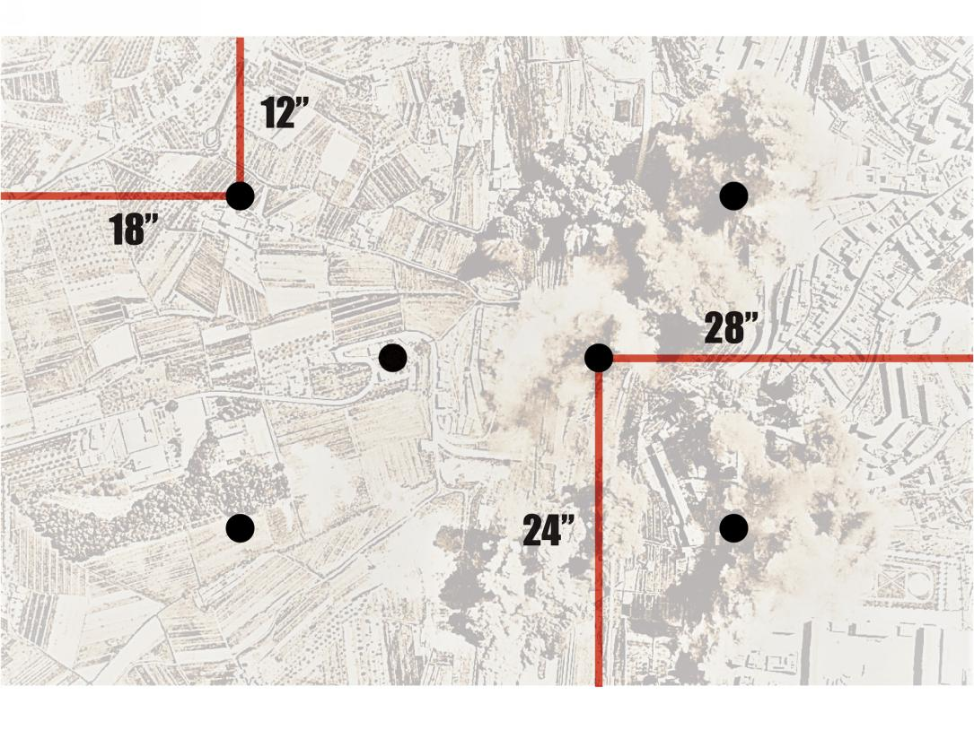依下图所示，放置6个任务目标点

**Seize Ground Bonus Point:** If a player holds or contests 5 or more objectives at the end of their player turn, gain 1 point.

*For an objective to be contested, both players have models within 3” of it but neither controls it. This typically occurs because both players have an equal number of models within range of the objective and either none of them are Objective Secured, or all of them are.*

*<夺取地盘>额外得分：若一位玩家在其玩家回合结束时，控制或争夺5个或更多的目标点，则得1分。“争夺”目标点，指对局双方都有模型进入目标点3寸以内，但均未控制该目标点。此类情况通常出现在双方玩家在目标点周围有相同数量的模型，且均具有或均不具有占点相关规则。*

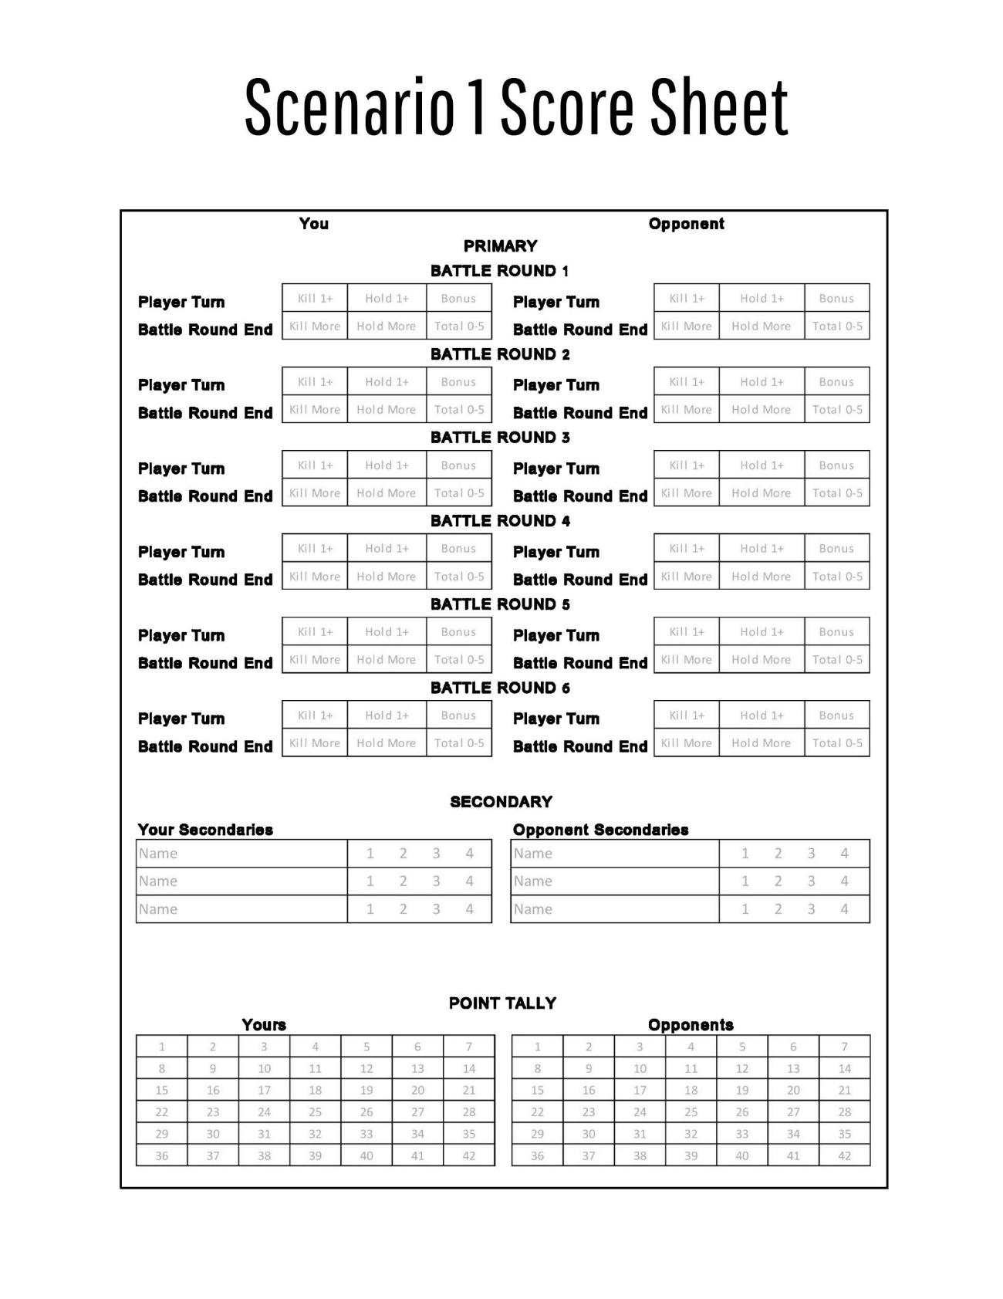

# Scenario 2: Cut to the Heart

### Deployment: Random

### 3 objectives: Each player places 1 objective in their deployment zone more than 6” from a table edge and 12” from any other objective. 1 objective is placed in the middle of the table.

任务场景2：直刺心脏

部署方式：随机决定

任务目标点：共3个目标点。每位玩家在其部署区内，距离桌边6寸以上，距离其他目标点12寸以上的任意位置，各放置1个目标点；战场正中心放置1个目标点。

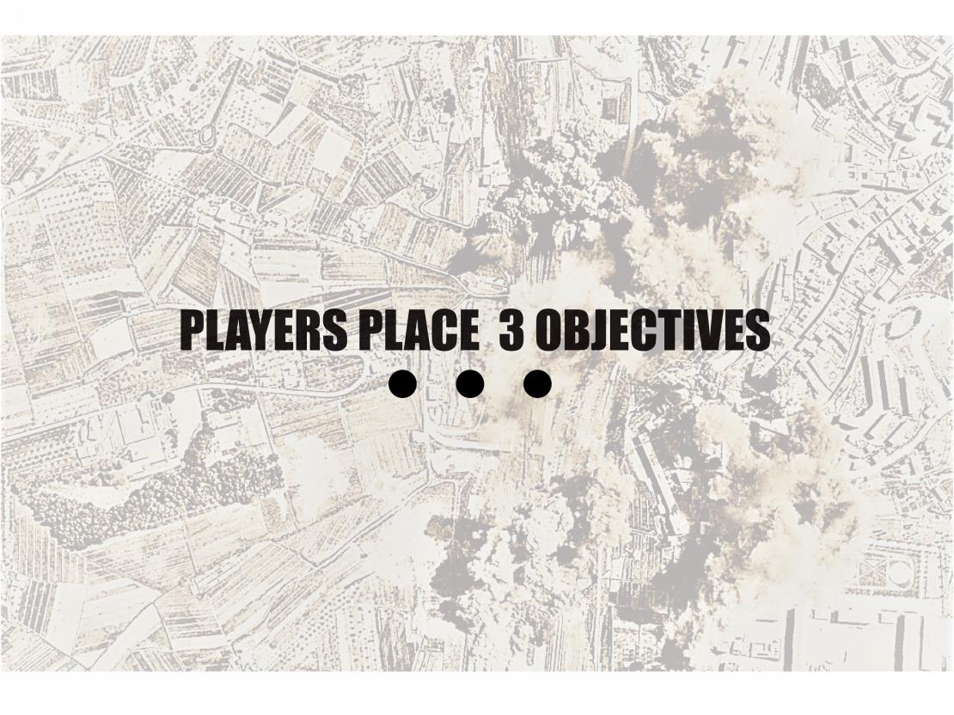

**Cut to the Heart Bonus Point:** If a player controls the center objective and their opponent’s objective at the end of their player turn, they gain 1 point.

<直刺心脏>额外得分：若一位玩家在其玩家回合结束时，同时控制中心目标点和对手玩家部署区内的目标点，该玩家得1分。

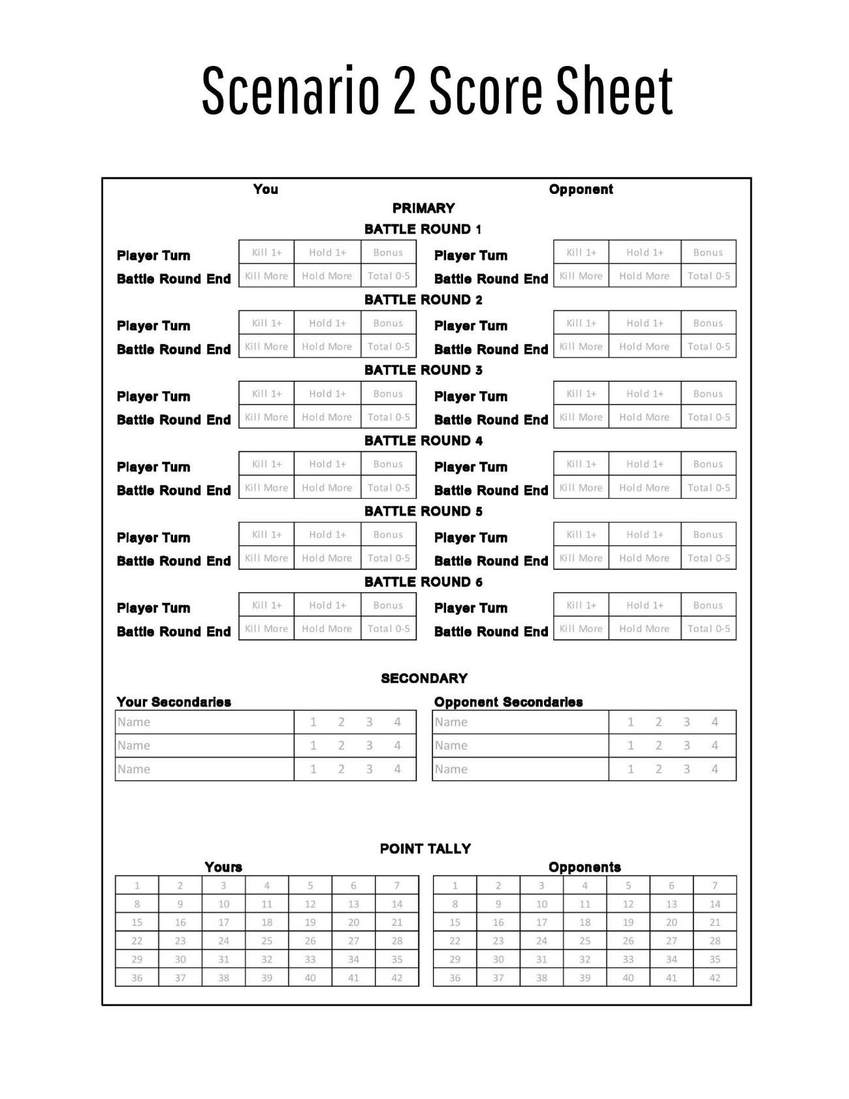

# Scenario 3: Nexus Control

### Deployment: Random

### 4 objectives placed as shown:

任务场景3：节点控制

部署方式：随机决定

任务目标点：依下图所示，放置4个目标点。

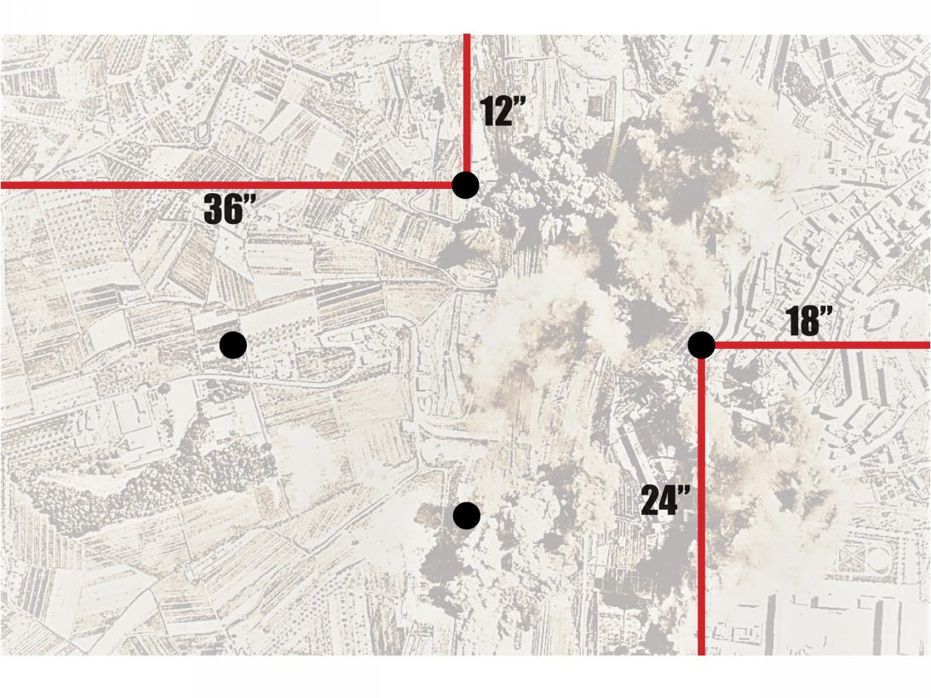

**Nexus Control Bonus Point:** If a player holds all four objectives at the end of their player turn, they score 1 point.

<节点控制>额外得分：若一位玩家在其玩家回合结束时，同时控制全部4个目标点，该玩家得1分。

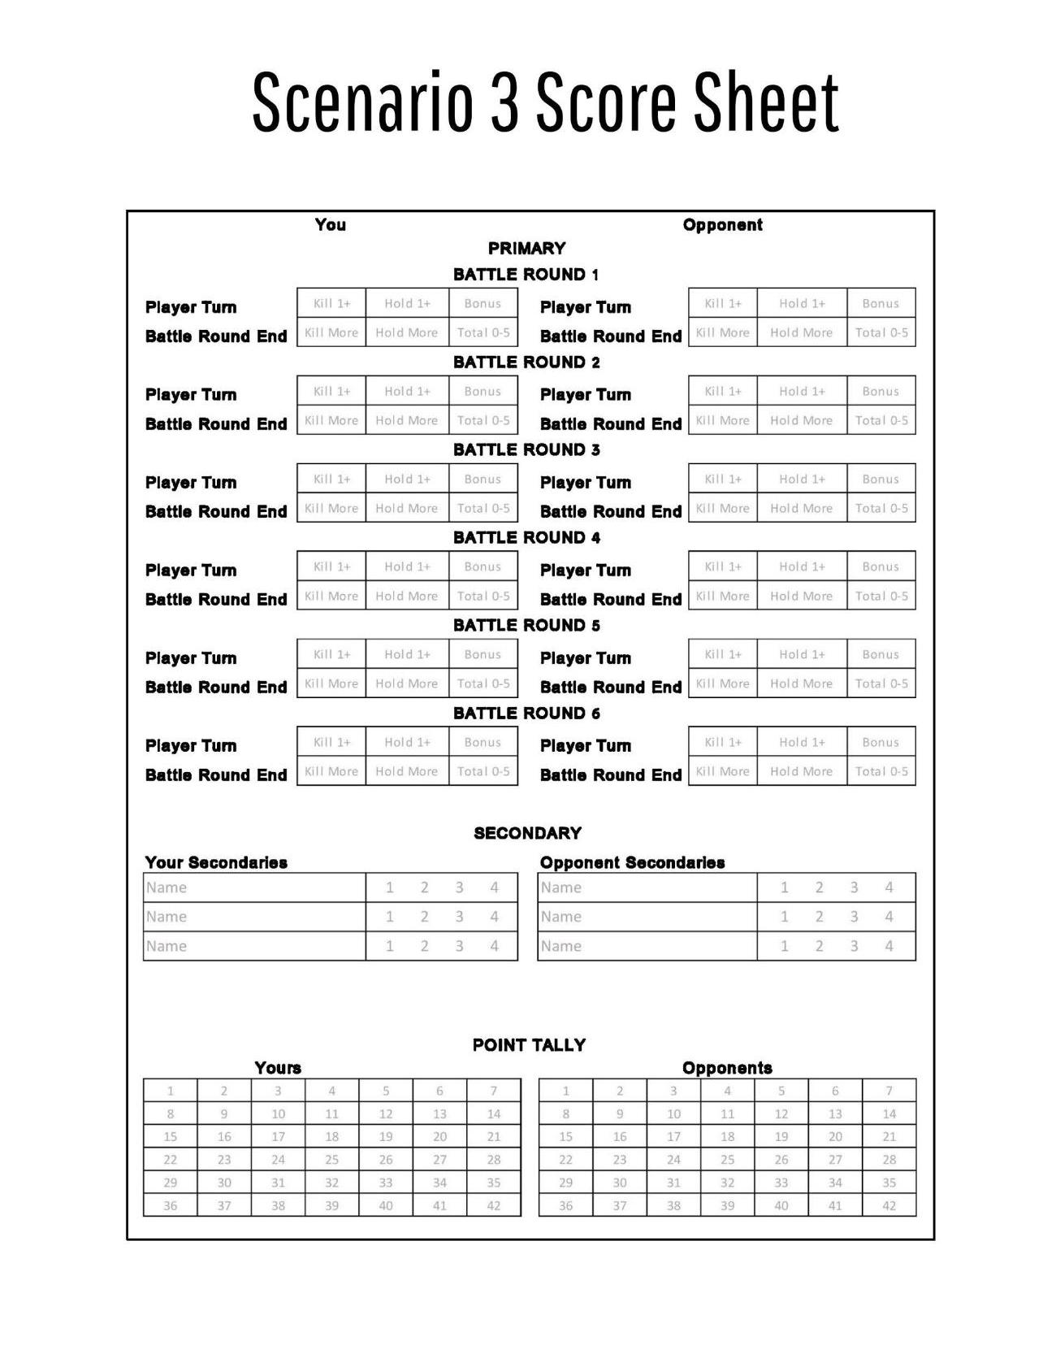

# Scenario 4: Precious Cargo

### Deployment: Random

### 4 objectives placed as shown:

任务场景4：珍贵货物

部署方式：随机决定

任务目标点：依下图所示，放置4个目标点。

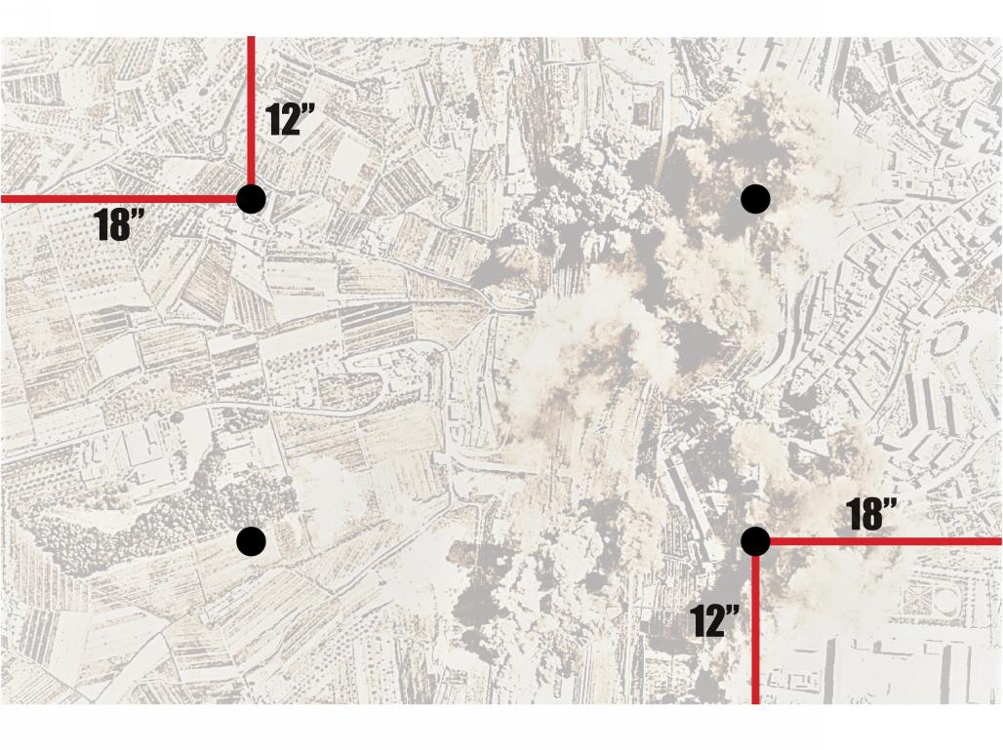

**Precious Cargo Bonus Point:** Before the game begins, each player chooses a separate objective--their *Priority Objective*--to defend starting with the player that chose their deployment zone first. After deployment zones have been determined but before deployment, each player may move their *Priority Objective* in any direction up to 6” from it’s original position so long as it is more than 6” from a table edge and 12” from another objective.

If a player holds their opponent’s *Priority Objective* at the end of their player turn, score 1 point.

<珍贵货物>额外得分：对局开始前，每位玩家选择一个目标点作为其首要目标点，由选择部署区域图的那位玩家先开始选择，且每位玩家需选择不同的目标点。在部署区域图选定后，单位部署之前，每位玩家可以移动他们的首要目标点，离开初始位置至多6寸，且应距战场边缘6寸以上，距其他目标点12寸以上。

若一位玩家在其玩家回合结束时，控制了对手玩家的首要目标点，则得1分。

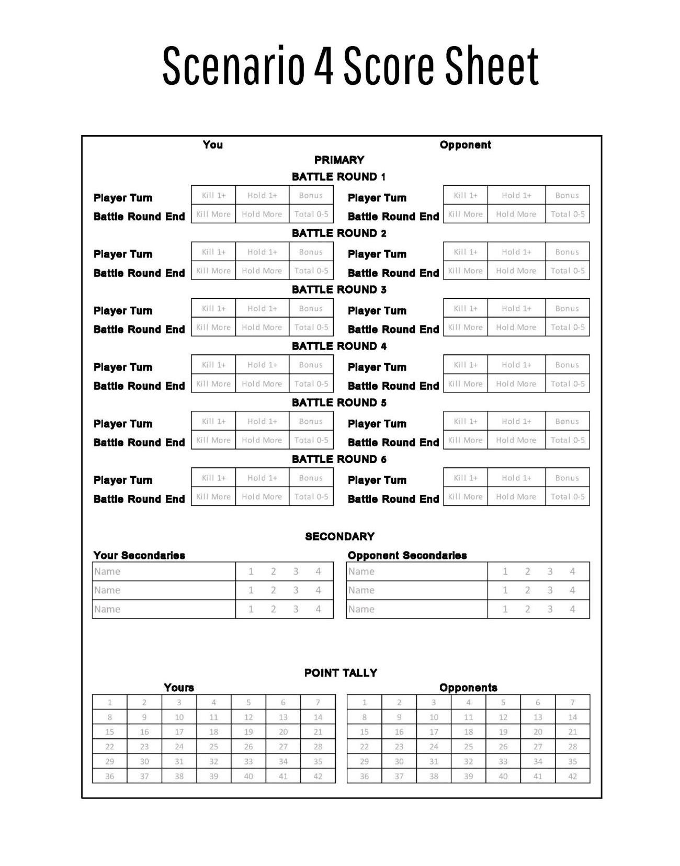

# Scenario 5: Crucible of Champions

### Deployment: Random

### 5 objectives placed as shown:

任务场景5：冠军试炼

部署方式：随机决定

任务目标点：依下图所示，放置5个目标点。

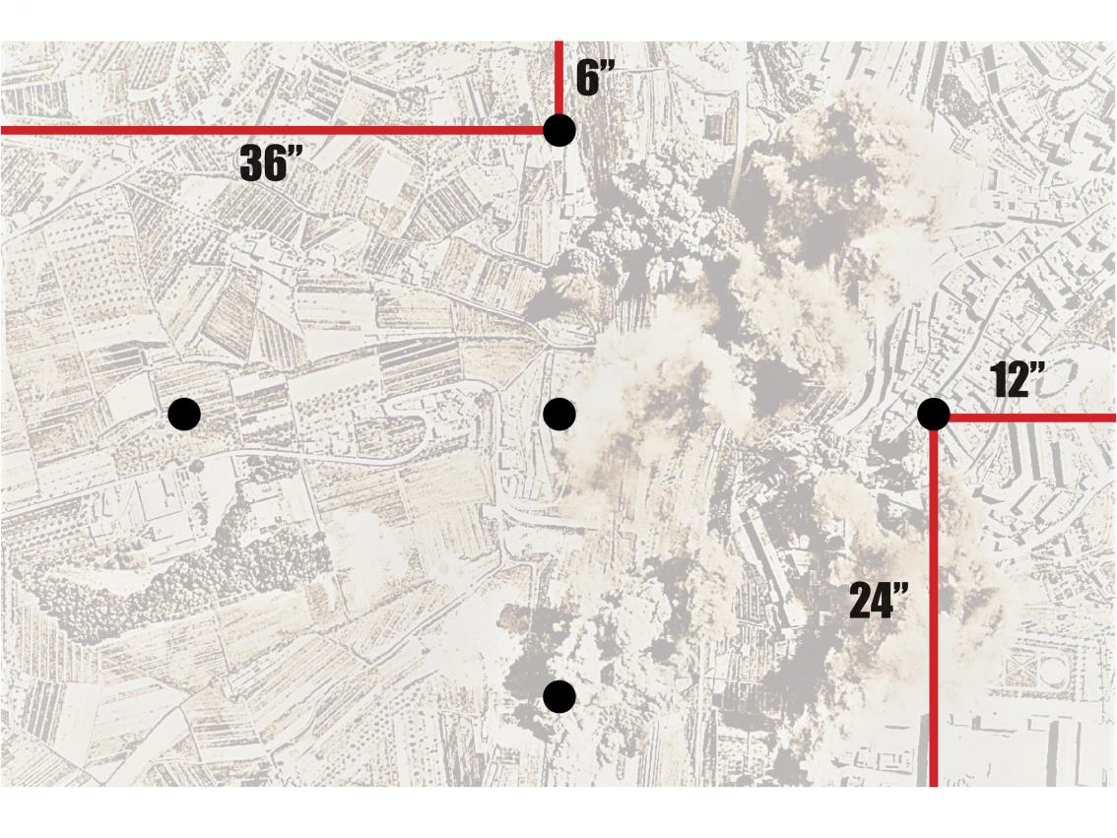**Crucible of Champions Bonus Point:** If a player has three models with the character keyword in scoring range of three different objectives at the end of their player turn, they score 1 point.

<冠军试炼>额外得分：若一位玩家在其玩家回合结束时，在3个不同的目标点控制范围内有3个具有角色关键词的模型，则得1分。

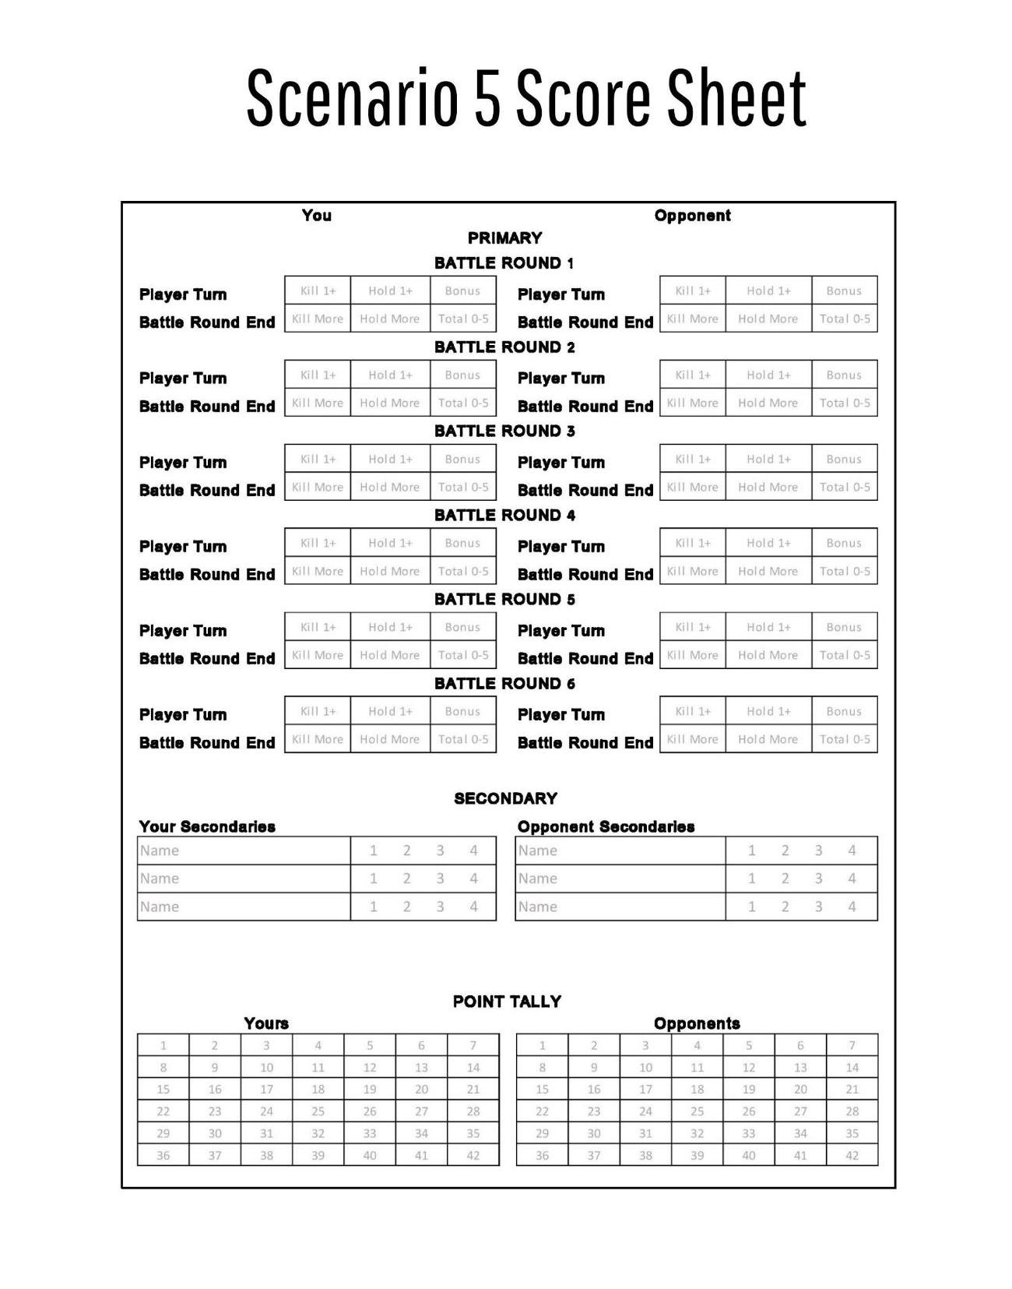

Standard Deployment Maps

### 1. Spearhead Assault

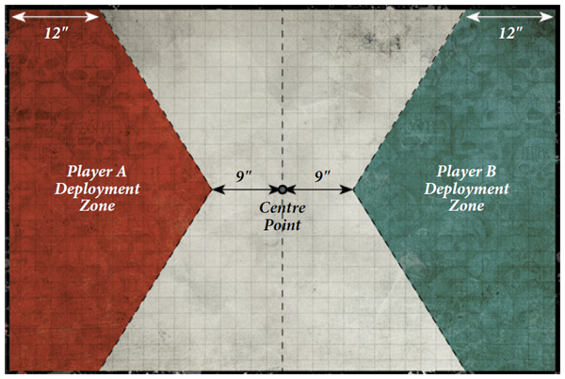

### 2. Dawn of War

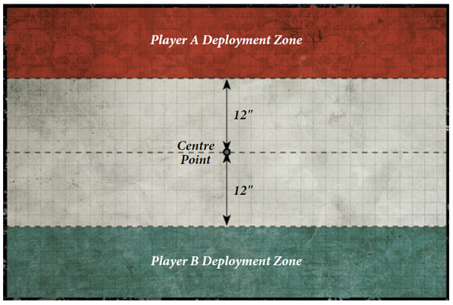

### 3. Search and Destroy

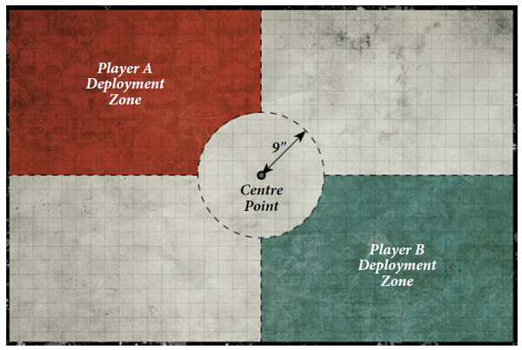

### 4. Hammer and Anvil

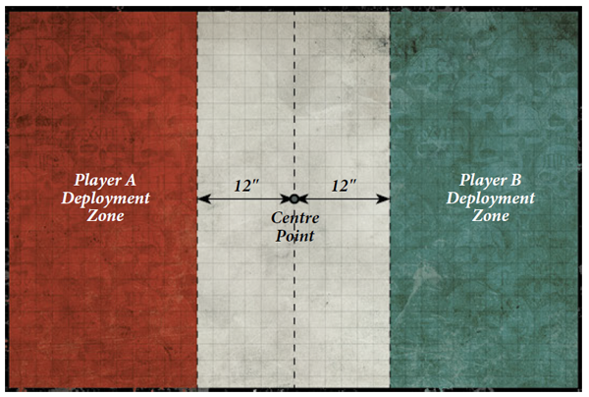

### 5. Front-line Assault

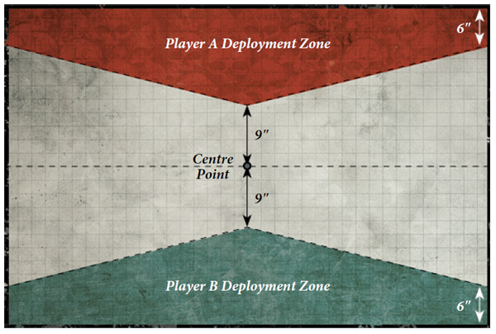

### 6. Vanguard Strike

